The Heart Of City
TOUR OVERVIEW
DAY 1: BIA – COLOMBO
Arrive from the airport and meet and greet by Beyond Borders travels Assistant and proceed to Colombo
DAY 2: COLOMBO CITY
Breakfast from the hotel and proceed to Colombo city
Overnight stay at 3* hotel
DAY 3: COLOMBO CITY
Breakfast from the hotel
Day leisure
Overnight stay at 3* hotel
DAY 4: COLOMBO – BIA
Breakfast from the hotel
Check out and proceed to BIA
Duration:3 days/2 nights
Destinations:Colombo
Duration:4 days/3 nights
Destinations:Colombo
US$ 200
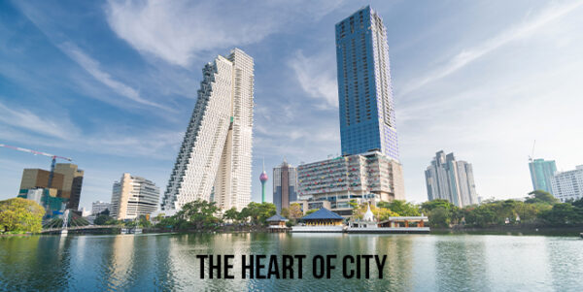
A Classic Of The City
TOUR OVERVIEW
DAY 1: BIA – COLOMBO
Arrive from the airport and meet and greet by Beyond Borders travels Assistant and proceed to Colombo
DAY 2: COLOMBO CITY
Breakfast from the hotel and proceed to Colombo city
Overnight stay at 4* hotel
DAY 3: COLOMBO CITY
Breakfast from the hotel
Day leisure
Overnight stay at 4* hotel
DAY 4: COLOMBO – BIA
Breakfast from the hotel
Check out and proceed to BIA
Duration:4 days/3 nights
Destinations:Colombo
US$ 300
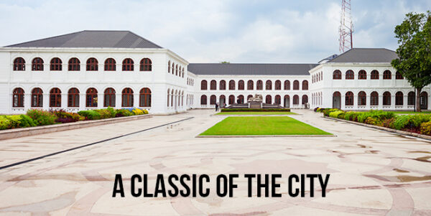

Glamour of Sri Lanka

TOUR OVERVIEW
DAY 1: BIA – COLOMBO
Arrive from the airport and meet and greet by Beyond Borders travels Assistant and proceed to Colombo
DAY 2: COLOMBO CITY
Breakfast from the hotel and proceed to Colombo city
Overnight stay at 5* hotel
DAY 3: COLOMBO CITY
Breakfast from the hotel
Day leisure
Overnight stay at 5* hotel
DAY 4: COLOMBO – BIA
Breakfast from the hotel
Check out and proceed to BIA
Duration:4 days/3 nights
Destinations: Colombo
US$ 499
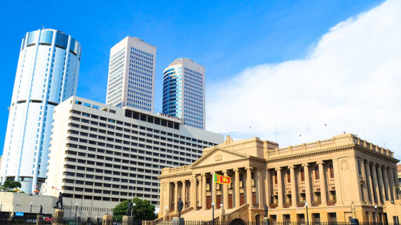

Sunbath on Sands Standard
TOUR OVERVIEW
DAY 1: BIA – COLOMBO
Arrive from the airport and meet and greet by Beyond Borders travels Assistant and proceed to Colombo in Luxury Vehicle
Check-in at hotel for lunch
Evening Nightlife at Bellagio Entertainment (Free Coupons, Food & Beverages)
Overnight stay at Colombo 5* Hotel
DAY 2: COLOMBO – BENTOTA
After breakfast from the hotel and proceed to Bentota
Lunch at 5* Restaurant
A route visiting Madu riverboat ride, turtle hatchery, fish farm and water sports activity’s
Evening Relax at the beach
Dinner and overnight stay at 5* hotel
DAY 3: BENTOTA – COLOMBO
After breakfast from the hotel and proceed to Colombo with Luxury transport Service
En route City tour of Colombo
Check-in for lunch at 5* hotel
Evening Night Life at Bellagio Entertainment (free entrance & food and beverages)
Overnight stay at 5* star hotel in Colombo
DAY 4: COLOMBO – BIA
After breakfast form the hotel and proceed Airport for Departure
Duration:4 days/3 nights

Destinations: Colombo, Bentota
US$ 999
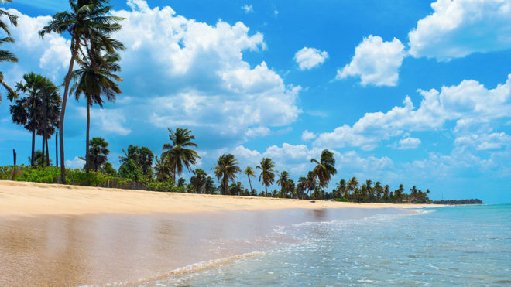

Sunbath on Sands Deluxe
TOUR OVERVIEW
DAY 1: BIA – COLOMBO
Arrive from the airport and meet and greet by Beyond borders travels Assistant and proceed to Colombo in Luxury Vehicle
Check in at hotel for lunch
Evening Nightlife at Bellagio Entertainment (Free Coupons, Food & Beverages)
Overnight stay at Colombo 5* Hotel
DAY 2: COLOMBO – BENTOTA
After breakfast from the hotel and proceed to Bentota in Luxury Helicopter Service
Lunch at 5* Restaurant
Evening Relax at the beach
Dinner and overnight stay at 5* hotel
DAY 3: BENTOTA
After breakfast from the hotel and proceed to do Leisure activity’s
Madu river boat ride, Turtle hatchery Kosgoda, water Sports, Explorer Galle dutch fort
Lunch at 5* Restaurant
Dinner and overnight stay at 5* hotel in Bentota
DAY 4: BENTOTA – COLOMBO
After breakfast from the hotel and proceed to Colombo with Luxury transport Service
En route City tour of Colombo
Check-in for lunch at 5* hotel
Evening Night Life at Bellagio Entertainment (free entrance & food and beverages)
Overnight stay at 5* star hotel in Colombo
DAY 5: COLOMBO – BIA
After breakfast form the hotel and proceed Air port for Departure
Duration:5 days/4 nights

Destinations: Colombo, Bentota
US$ 1,999
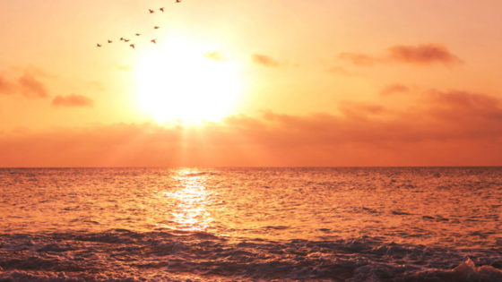

Hill Country Tour
TOUR OVERVIEW
DAY 1: BIA – NEGOMBO
Arrive from the airport and meet and greet by Beyond Borders travels assistant will proceed to Negombo
Check-in at the hotel for lunch and relax
Dinner and overnight stay at Negombo hotel
Negombo is a major city in Sri Lanka, situated on the west coast and at the mouth of the Negombo Lagoon, in Western Province, Sri Lanka. Negombo is the fourth largest city in Sri Lanka and it is the largest city in Gampaha District. Negombo is also the administrative capital centre of the Negombo Division. It is one of the major commercial hubs in Sri Lanka with about 144,551 inhabitants within city limits. It is approximately 35 km north of Colombo City. Negombo is known for its huge and old fishing industry, with busy fish markets and long, sandy beaches. Negombo is the most westernized, vibrant city and it is one of the major tourist destinations in the country. The main international airport of Sri Lanka is in Negombo Metropolis.
DAY 2: NEGOMBO – KANDY
After breakfast from the hotel and proceed to Kandy
En route Visiting temple of tooth relic
Evening Cultural Show
Dinner and overnight stay at Kandy Hotel
Kandy lovely exotic city, the Hill Capital and last stronghold of the Sinhala Kings is a UNESCO World Heritage Site which retains an aura of grandeur, time has not affected. Encircled by hills, with a tranquil lake in its centre, it is the site of the renowned temple that enshrines the Tooth Relic of the Buddha and the Royal Botanical gardens – home to one of the world’s best collections of Orchids. A cultural sanctuary where many legends, traditions and folklore are still lovingly kept alive, Kandy and its satellite villages are the centre of the islands handicraft industry (items of wood, brass & silver) exquisite silver or gold jewellery and precious gems of many varieties including the world’s best blue and star sapphires. The highlight of the city’s calendar is the Esala Perahera, when a replica of the casket enclosing the Tooth is taken in procession for ten glittering nights in July/August by exotically costumed dancers, drummers and approximately 100 Elephants.
DAY 3: KANDY
After Breakfast from the hotel and proceed to visit
Pinnawela elephant orphanage, royal botanical garden, Spice Garden and city tour of Kandy
Lunch at Locale restaurant
Dinner and overnight stay at Kandy hotel
Pinnawela Elephant Orphanage – set amongst the verdant hills of Kegalle is a unique orphanage, where the tiny tots weigh 60 kg or more. This is the Pinnewela Elephant Orphanage, the world’s first and only elephant orphanage established to feed, nurse and house young elephants lost or abandoned by their mothers. Other occupants are elephants displaced from their natural environs by development projects or those found wounded. Visitors could see the baby elephants being fed milk from gigantic feeding bottles or bathed in the river which flows nearby – an unforgettable sight! Established in 1975, by the Wildlife Department and National Zoological gardens which subsequently led to a breeding programme through which more than twenty-five elephants have been born since 1984.
DAY 4: KANDY – COLOMBO
After breakfast from the hotel and proceed to Colombo
Check-in for lunch at hotel
Evening nightlife at Bellagio Entertainment (Free entrance, Food and valid coupons)
Overnight stay at Colombo Hotel
Colombo is the commercial capital and largest city of Sri Lanka. According to the Brookings Institution, Colombo metropolitan area has a population of 5.6 million and 752,993 in the city proper. It is the financial center of the island and a popular tourist destination. It is located on the west coast of the island and adjacent to Sri Jayawardenepura Kotte, the legislative capital of Sri Lanka. Colombo is often referred to as the capital since Sri Jayawardenepura Kotte is within the urban area of, and a satellite city of, Colombo. It is also the administrative capital of Western Province, Sri Lanka and the district capital of Colombo District. Colombo is a busy and vibrant place with a mixture of modern life and colonial buildings and ruins. It was the legislative capital of Sri Lanka until 1982.Due to its large harbor and its strategic position along the East-West sea trade routes, Colombo was known to ancient traders 2,000 years ago. It was made the capital of the island when Sri Lanka was ceded to the British Empire in 1815, and its status as capital was retained when the nation became independent in 1948. In 1978, when administrative functions were moved to Sri Jayawardenepura Kotte, Colombo was designated as the commercial capital of Sri Lanka.
DAY 5: COLOMBO
After breakfast from the hotel and proceed to do city tour of Colombo
Lunch at luxury five-star restaurant
Evening leisure at Bellagio Entertainment
Overnight stay at Colombo hotel
City Tour: While on your city tour in Colombo you may visit famous places including Galle Face Green, the Viharamahadevi Park, National Museum, Twin World Trade Center towers, Old Parliament Building, Fort district, Independence Hall at Independence Square, and prominent Buddhist, Hindu, Islam and Christian places of worship. (Entrance fees to sites not included). For shopping, you may visit ODEL, House of Fashion, Beverly Street, Majestic City, Noritake, etc.
DAY 6: COLOMBO – BIA
After breakfast form the hotel and proceed Airport for Departure
Duration:6 days/5 nights
Destinations: Negombo, Kandy, Colombo
US$ 2,999
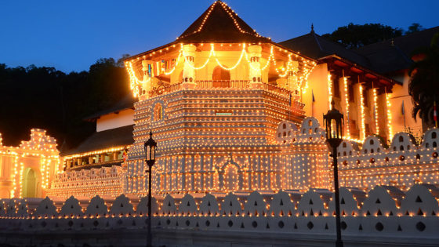

Discover Sri Lanka
TOUR OVERVIEW
DAY 1: BIA – KANDY
Arrive from the airport and meet and greet by our assistant of Beyond Borders Travels Will Proceed to Kandy hotel
Check-in for lunch at hotel and relax for the day
Evening cultural show
Dinner and overnight stay at Kandy hotel
Kandy lovely exotic city, the Hill Capital and last stronghold of the Sinhala Kings is a UNESCO World Heritage Site which retains an aura of grandeur, time has not affected. Encircled by hills, with a tranquil lake in its centre, it is the site of the renowned temple that enshrines the Tooth Relic of the Buddha and the Royal Botanical gardens – home to one of the world’s best collections of Orchids. A cultural sanctuary where many legends, traditions and folklore are still lovingly kept alive, Kandy and its satellite villages are the centre of the islands handicraft industry (items of wood, brass & silver) exquisite silver or gold jewelry and precious gems of many varieties including the world’s best blue and star sapphires. The highlight of the city’s calendar is the Esala Perahera, when a replica of the casket enclosing the Tooth is taken in procession for ten glittering nights in July/August by exotically costumed dancers, drummers and approximately 100 Elephants.
DAY 2: KANDY
After Breakfast from the hotel and proceed to Visit (Pinnawela elephant orphanage, royal botanical garden, Temple of tooth relic and city tour of Kandy)
Lunch at local restaurant
Evening relax city walk
Dinner and Overnight stay at Kandy Hotel
Temple of the Tooth Relic, Kandy The Temple of the Sacred Tooth relic of the Buddha is the most important temple for the Sri Lankan Buddhists and was built in the 16th Century A.D. by king Wimaladharmasooriya, solely for the purpose of housing the tooth relic.
DAY 3: KANDY – NUWARA ELIYA
After breakfast from the hotel and proceed Nuwara Eliya.
En-route visit Ramboda Hanuman temple, Hakagala botanical garden and Sita Amman Kovil
Lunch at Locale restaurant
Evening tea plucking experience in Green Path
Dinner and overnight stay in Nuwara Eliya hotel
Nuwara Eliya – Sri Lanka’s premier hill resort with a fine bracing mountain climate, Nuwara Eliya is also the heart of Sri Lanka’s tea country, producing some of the world’s best tea. The mountain slopes and valleys are a carpet of velvety green tea plantations, interspersed with gushing streams and tumbling waterfalls. Red or green roofed plantation bungalows, English country style homes and hotels with lovely flower gardens, a fine 18-hole golf course and a racecourse gives Nuwara Eliya a decidedly British character.

DAY 4: NUWARA ELIYA
After breakfast from the hotel and proceed to visit
Devon falls, amazing words end, Ravana Falls and Tea plantation
Lunch at local restaurant
Dinner and overnight stay at Nuwara Eliya hotel
Tea Plantation – visit a tea plantation and a tea factory where one the best teas in the world is produced. You will be told all about the process of manufacturing tea and also see how tea is graded. Taste a cup of pure Ceylon tea in the factory.
DAY 5: NUWARA ELIYA – BENTOTA
After breakfast from the hotel and proceed to Bentota
Check-in for lunch at hotel
Evening relax at the beach
Dinner and overnight stay at Bentota hotel
Bentota is a coastal town in Sri Lanka, located in the Galle District of the Southern Province, governed by an Urban Council. It is approximately 65 kilometers (40 mi) south of Colombo and 56 kilometers (35 mi) north of Galle. Bentota is situated on the southern bank of the Bentota River mouth, at an elevation of 3 meters (9.8ft) above the sea level. The name of the town is derived from a mythical story which claims a demon named ‘Bem’ ruled the tota or river bank.
DAY 6: BENTOTA
After breakfast from the hotel and proceed to do leisure activity in Bentota (Madu river boat ride, Turtle hatcher and water sports activity )
Lunch at Local restaurant
Dinner and overnight stay at Bentota hotel
Madu Ganga -The Buddhist Amarapura Nikaya sect had its first upasampada (higher ordination ceremony) on a fleet of boats anchored upon it in 1803. The Buddhist Kothduwa temple is situated on an isolated island in the lake. Together with the smaller Randombe Lake, to which it is connected by two narrow channels, it forms the Madu Ganga wetland. Its estuary and the many mangrove islets on it constitute a complex coastal wetland ecosystem. In has high ecological, biological and aesthetic significance, being home to 303 species of plants belonging to 95 families and to 248 species of vertebrate animals. It might be one of the last remaining tracts of pristine mangrove forests in Sri Lanka. The inhabitants of its islets produce peeled cinnamon and cinnamon oil. The Maduganga Wetland was declared in 2003, in terms of the Ramsar Convention.

DAY 7: BENTOTA – COLOMBO
After Breakfast from the hotel and proceed to Colombo
Lunch at local restaurant
Evening Entertainment at Sri Lanka’s largest casino Bellagio (Free food, Free Entrance and Valid Coupons)
Overnight stay at Colombo hotel
Colombo is the commercial capital and largest city of Sri Lanka. According to the Brookings Institution, Colombo metropolitan area has a population of 5.6 million and 752,993 in the city proper. It is the financial center of the island and a popular tourist destination. It is located on the west coast of the island and adjacent to Sri Jayawardenepura Kotte, the legislative capital of Sri Lanka. Colombo is often referred to as the capital since Sri Jayawardenepura Kotte is within the urban area of, and a satellite city of, Colombo. It is also the administrative capital of Western Province, Sri Lanka and the district capital of Colombo District. Colombo is a busy and vibrant place with a mixture of modern life and colonial buildings and ruins. It was the legislative capital of Sri Lanka until 1982.Due to its large harbor and its strategic position along the East-West Sea trade routes, Colombo was known to ancient traders 2,000 years ago. It was made the capital of the island when Sri Lanka was ceded to the British Empire in 1815, and its status as capital was retained when the nation became independent in 1948. In 1978, when administrative functions were moved to Sri Jayawardenepura Kotte, Colombo was designated as the commercial capital of Sri Lanka.
DAY 8: COLOMBO
After breakfast from the hotel and proceed to do city tour of Colombo
Lunch at locale restaurant
Evening relax city walk
Dinner and overnight stay at Colombo Hotel
City Tour: While on your city tour in Colombo you may visit famous places including Galle Face Green, the Viharamahadevi Park, National Museum, Twin World Trade Center towers, Old Parliament Building, Fort district, Independence Hall at Independence Square, and prominent Buddhist, Hindu, Islam and Christian places of worship. (Entrance fees to sites not included). For shopping, you may visit ODEL, House of Fashion, Beverly Street, Majestic City, Noritake, etc.
DAY 9: COLOMBO – BIA
After breakfast from the hotel proceed to airport for departure
Duration:9 days/8 nights
Destinations: Kandy, Nuwara Eliya, Bentota, Colombo
US$ 3,999
